Nostradamus (Predicting Stock Price)
*Group Name: YA

1st CheongRok Yoon
dept. information System
Hanyang University
Seoul, Korea
dbscjdfhr@gmail.com

2nd ZiJian AN
dept. information System
Hanyang University
Seoul, Korea
azj535041051@hanyang.ac.kr

Abstract—Stocks are a "game" of probability. No matter what decision to buy or sell, there is no 100% correct or incorrect one. The potential of the stock market is amazing, and the risks are also great. When does the customer buy and when to sell. Its profit and loss depend on the customer's decision. We will develop an application software that can predict the stock market to help customers make decisions. This article focuses on how to design and implement applications through software engineering methods. The app is equipped with some features and deep learning technology.
Keywords: stock prediction, tensorflow, Android OS, deep learning, data analysis
- INTRODUCTION

The stock market has always been a persistent topic. Currency and stocks affect people differently. Some people become rich overnight due to inventory, while others become poor overnight. "Veterans" who have experience in stock trading can use their experience to buy and sell at an appropriate price. This is an ability that requires years of experience. According to the survey, 80% of new immigrants will be eliminated within three months to one year. In this process, most people are the result of blind follow and gambling psychology.
Generally, political factors, economic factors, corporate factors, and time series factors affect stock prices. Political factors include international and domestic political situations, relevant laws and policies issued by the government and other factors. There are many economic factors that affect stock prices, which are mainly affected by the growth rate of gross domestic product (GDP). If the GDP growth rate is large, it will usually stimulate stock investment and increase the stock price. Conversely, if GDP growth is slow or negative, the stock price will fall. The company factor mainly depends on the company's profitability. Generally, the stock price and the company's profit change simultaneously. Finally, time series factors affect stock prices. Time series factors include past stock price and trading volume. These factors make it possible to analyze market psychology and trend.
Analyzing political, economic, corporate factors is called “fundamental analysis”. Fundamental analysts study anything that can affect the security's value, from macroeconomic factors such as the state of the economy and industry conditions to microeconomic factors like the effectiveness of the company's management. Analyzing Time series factors is called “technical analysis”. Technical analysis examines and predicts price movements in the financial markets, by using historical price charts and market statistics. It is based on the idea that if a trader can identify previous market patterns, they can form a fairly accurate prediction of future price trajectories.
But for new people entering the stock market for the first time, they need to learn a lot of relevant knowledge and cultivate insights. At this time, there is a software Nostradamus that can help new people make decisions. What is Nostradamus? Nostradamus is an application that predicts the stock market and helps customers make investment decisions. This app will use deep learning technology in order to do technical analysis. It aims to make it possible for people to save time to study technical analysis. Customers can find the stocks they want to invest through Nostradamus and make good judgments based on the data analysis obtained.

TABLE I
ROLE ASSIGNMENTS

Roles | Name | Task description
User | CheongRok Yoon | the people who want to invest stock and want statistical help.
Customer | ZiJian AN | Special personnel is required to supervise and communicate, communicate problems promptly.  Clarify requirements, development environment, and development time.  Determine the development cycle and time, delivered within a certain time.
Software developer | CheongRok Yoon | Understand all the characteristics of the stock market and basic economic feature.  Manipulate data for use in deep learning  Provide customers with as useful information as possible for decision making.
Development manager | ZiJian AN | Communicate customer ideas and requirements with developers.  Ensure that the development team can work as efficiently as possible and complete the delivery within a certain time.  Regularly test, maintain, optimize, and improve product performance with developers.

- REQUIREMENTS

- Mobile application

- Run: This application will run on Android OS.

- Login screen

- Login: The login screen is the first page that users can see when they enter our application. If the username and password match our database, the user can log in to our application to use our application.

- Sign-up: New users who use this software for the first time need to register their own account. Users can choose to use their favorite numbers or meaningful numbers as their ID. User can choose to use their favorite numbers or meaningful numbers as their ID.

- ID/PW Search: When users forget their ID or password, this function can find their ID or password after the verification process.

- Browse

- Search: When the user logs in his ID, he jumps to the search function page. Users can use this function to find the stock information they care about.

- Main Page

1) Chart: The stock chart consists of opening price, closing price, the highest and lowest prices. Users can check the recent stock prices at a glance through chart.

- Performance: The performance button simulate the app using historical data. This shows how successful the program has been in price forecasting. User can see how reliable the app is through this.

- Result: This screen shows the prediction result of Nostradamus. It consists of prediction price, probability and volatility. User can use this result to make investment decision.

- Buy and Sell button:

- Bookmarks

- What bookmarks do: Bookmarks are the records saved when browsing stocks so that they can be viewed at any time in the future. Each user can add the data he cares about to the bookmark.

- Development environment

- Choice of development platform
- Selected platform and why
  - Windows10
We will going to use Windows10 OS platform. We will be using Windows 10. The first big reason is that the api provided by HTS (Home Trading System) of a Korean securities company is made window-friendly. Also, later we need data from Korean stocks to do deep learning. HTS provides high-quality data necessary for learning. So We chose windows. In addition, we are going to use Android~
- Used Programming Language and Why
2.1) Python 3.6
Python helps developers be productive and confident about the software they’re building. Benefits that make Python the best fit for machine learning and AI-based projects include simplicity and consistency, access to great data analysis libraries(NUMPY, SCIPY, PANDAS, SEABORN) and frameworks for AI and machine learning (TensorFlow, Keras, Scikit-learn). In addition, Python has wide community to study. There are Python forums and an active exchange of experience related to machine learning solutions. For any task, the chance is pretty high that someone else out there has dealt with the same problem. This is why our team chooses Python3.6.
2.2) R4.0
R is generally applied when need to analyze and manipulate data for statistical purposes. R has packages such as Gmodels, Class, Tm, and RODBC that are commonly used for building machine learning projects. These packages allow developers to implement machine learning algorithms. This language can give you in-depth statistical analysis whether you’re handling data from an IoT device or analyzing financial models. What’s more, if your task requires high-quality graphs and charts, you may want to use R. With ggplot2, ggvis, googleVis, Shiny, rCharts, and other packages, R’s capabilities are greatly extended, helping you turn visuals into interactive web app.

2.3) Android Studio
Android Studio is built-in based on Intellij IDEA, which can provide the shortest possible turnaround time for coding and running workflows. With the Apply Changes feature of Android Studio, you can push code and resource changes to the running application without restarting the application (in some cases, you don’t need to restart the current Activity). When you want to deploy and test small incremental changes while maintaining the current state of the device, this flexibility helps you control the scope of application restarts. Android Studio includes project and code templates, allowing you to easily add existing features such as navigation drawer and ViewPager. You can start with code templates, or even right-click an API in the editor and select Find Sample Code to search for examples. In addition, you can also import a full-featured application from GitHub directly on the "Create Project" screen. Android Studio fully supports the modification of C/C++ project files, enabling you to quickly build JNI components in your application. IDE provides syntax highlighting and reconstruction functions for C/C++, and also provides a debugger based on LLDB, which allows you to debug Java and C/C++ code at the same time. The build tool can also execute CMake and ndk-build scripts without any modification, and then add shared objects to the APK.

- Cost estimation (Software)
TABLE II
COST ESTIMATION
Category | Name and Version | Cost
Operating System | Windows10 1909 | £119.99
IDE | Android Studio version-4.0.2 | 0
Text editor | Sublime text 3 | 0
Communication | KakaoTalk | 0
Documentation | Word | 0
Programming Language-Back end | Python R | 0
Programming Language-Front end | Java | 0

- Software in use


Fig.1. Android Studio

Android Studio is an official integrated development environment (IDE) based on IntelliJ IDEA and suitable for developing Android applications. In addition to IntelliJ's powerful code editor and developer tools, Android Studio also provides more features that can improve the efficiency of Android application compilation, such as:

- Flexible compilation system based on Gradle.
- Fast and feature-rich simulator.
- Unified environment (for you to develop applications for all Android devices).
- Apply Changes function can push code and resource changes to the running application without restarting the application.
- Code template and GitHub integration, can help you create common application functions and import sample code.
- A large number of testing tools and frameworks.
- Lint tool, able to find performance, ease of use and version compatibility issues.
- C++ and NDK support.
- Built-in support for Google Cloud Platform for easy integration of Google Cloud Messaging and App Engine.

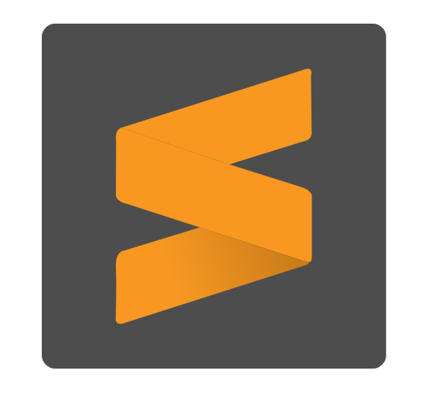
Fig. 2. Sublime text 3

Sublime Text is a proprietary cross-platform source code editor with a Python application programming interface (API). It natively supports many programming languages and markup languages, and functions can be added by users with plugins, typically community-built and maintained under free-software licenses.

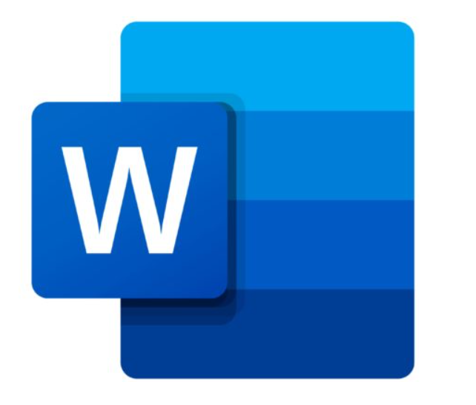
Fig. 3. Word

Word for Windows is available stand-alone or as part of the Microsoft Office suite. Word contains rudimentary desktop publishing capabilities and is the most widely used word processing program on the market. Word files are commonly used as the format for sending text documents via e-mail because almost every user with a computer can read a Word document by using the Word application, a Word viewer or a word processor that imports the Word format.

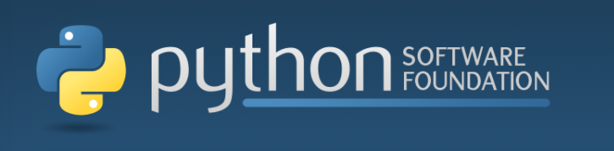

Fig. 3. Pytohn

Python is a cross-platform computer programming language. It is a high-level scripting language that combines interpretation, compilation, interactivity and object-oriented. It was originally designed to write automated scripts (shell). With the continuous update of the version and the addition of new language features, the more it is used for the development of independent and large-scale projects.

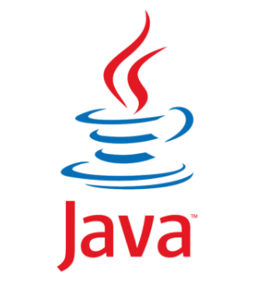
Fig. 5. Java

Java is an object-oriented programming language. The Java language has two characteristics: powerful and easy to use. As a representative of the static object-oriented programming language, the Java language implements the object-oriented theory very well, so that programmers can execute complex programming with elegant thinking. Java has the following characteristics: simplicity, object-oriented, distributed, robustness, security, platform independence and portability, multithreading and dynamics. Java can write desktop applications, web applications, distributed systems and embedded system applications.

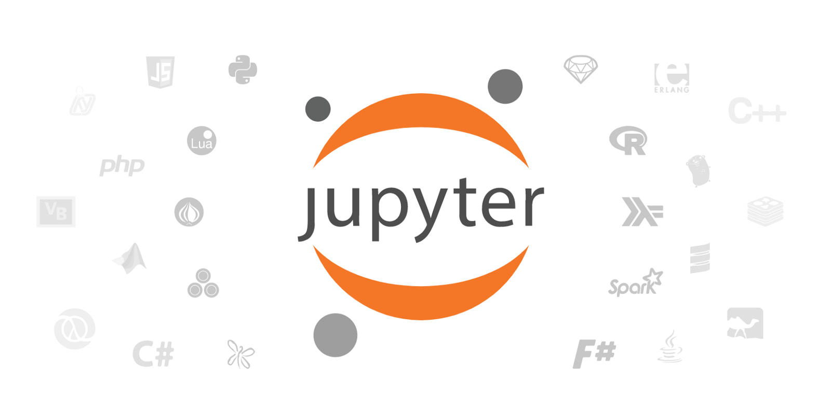
Fig.6. Jupyter Notebook

The Jupyter Notebook is an open source web application that you can use to create and share documents that contain live code, equations, visualizations, and text. Jupyter Notebook is maintained by the people at Project Jupyter.
Jupyter Notebooks are a spin-off project from the IPython project, which used to have an IPython Notebook project itself. The name, Jupyter, comes from the core supported programming languages that it supports: Julia, Python, and R. Jupyter ships with the IPython kernel, which allows you to write your programs in Python, but there are currently over 100 other kernels that you can also use.



Figure.7. R

R is a programming language and free software environment for statistical computing and graphics supported by the R Foundation for Statistical Computing. The R language is widely used among statisticians and data miners for developing statistical software and data analysis. Polls, data mining surveys, and studies of scholarly literature databases show substantial increases in popularity; as of September 2020, R ranks 9th in the TIOBE index, a measure of popularity of programming languages

- Task distribution
TABLE III
TASK DISTRIBUTION

Name | Task Distribution
CheongRok Yoon | Back-end (data analysis)
ZiJian AN | Front-end (display screen)
- SPECIFICATIONS

- Login Screen

- Login

This is the first screen where the user logs into the application login page. Users who enter our APP for the first time must register before they can enter. If the user logs in successfully, it will be verified by the internal identification system and then jump to the search page. When the user login ID or password is entered incorrectly, "wrong id or wrong password" is displayed. At this time, the user needs to input again. If the user enters the wrong password more than 5 times, it will be locked. Users can reset their passwords through email verification.

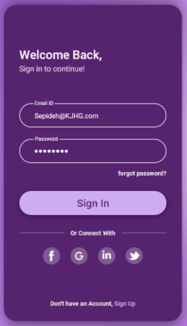

Fig. 8. Login

- Sign-up

When a user registers for an account, the user must use a unique name as his user name. If the name used by the user matches the name in the database, "duplicate" will be displayed and a new name will be required. The second step requires the user's email account as the ID when logging in. The third step when setting a password, the user must set a password within 15 digits. These include uppercase letters, lowercase letters, numbers and special symbols. Users need to click "I agree to this clause" to register their account. If users have Facebook, Google, In and Twitter accounts, they can connect to our APP to create an account.
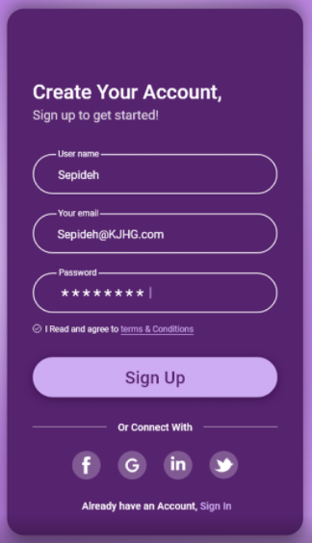

Fig. 9. Sign-up

- ID/PW Search

If the user forgets his password, he can verify and reset his new password through the email during registration. The user cannot use the old password in the past to reset the new password. If there is no matching object in the database to reset the new password, the password is considered successful.

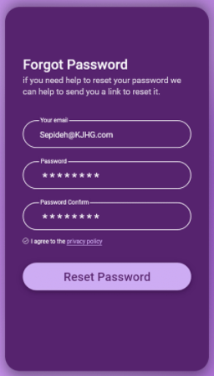

Fig. 10. ID/PW

- Browse
- Search

The search dialog is an interface component controlled by the Android system. After being activated by the user, the search dialog will be displayed at the top of the activity.
The Android system controls all events in the search dialog. When a user submits a query, the system will pass the query to the Activity you specify to process the search. The dialog box can also provide search suggestions while the user enters content.
Searchable Activity is an activity in your application that performs a search based on a query string and displays search results.
When the user performs a search in the search dialog or search widget, the system will start the searchable activity and pass the search query in the Intent to it through the ACTION_SEARCH operation. The searchable activity retrieves the query from the QUERY extra of the intent, then searches the data and displays the results.



Fig. 11. Chart

- Main Page
- Chart
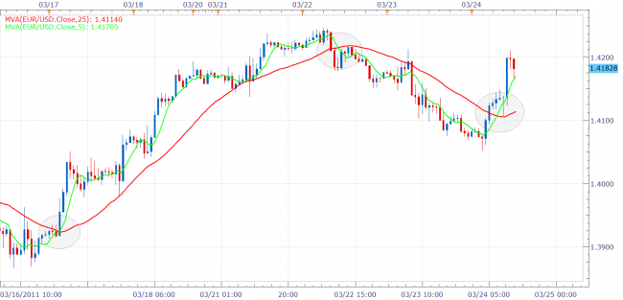
Fig. 12. Chart

In the stock market, charts allow people to see the stock market situation at a glance. So we will always have a stock chart on the main page. We provide customer with chart like above figure1.1. On the bar chart there are four values: open price, high price, low price, and closing price to indicate additional trends for that trading day. To draw a candle stick bar, open, high, low, and close price are required, but the DataFrame provided by HTS already has a column composed of the corresponding data. And We will use the data we receive to represent the moving average line. The moving average(MVA) line makes the chart easier to see by removing noise. Also, the moving average line can inform people of mid- to long-term trends. The formula for the moving average(MVA) line is as follows.
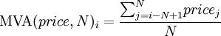
We use “KIUM Open API +” to acquire price data and draw real time chart through matplotlib library .

- Performance measurement
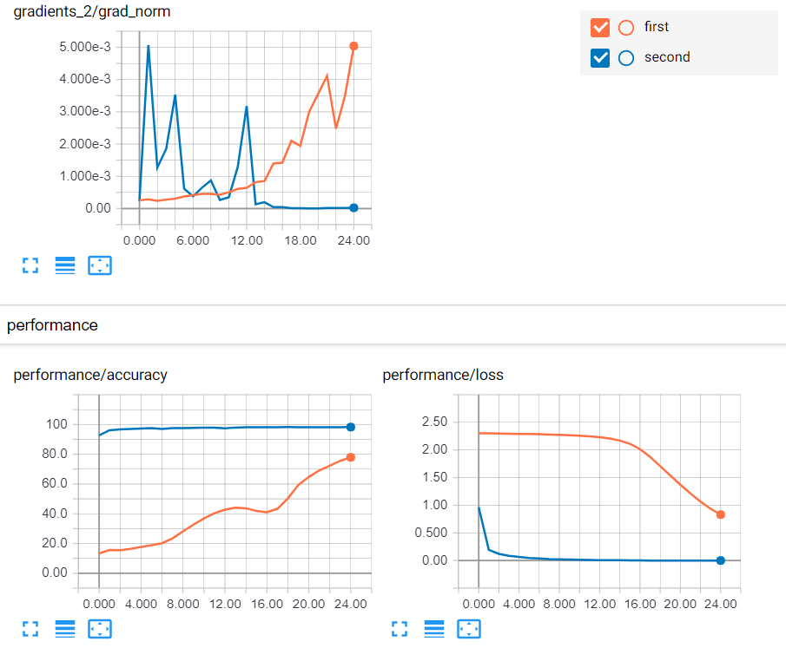
Fig.13. Tensorbord
The performance measurement button simulates the app to measure accuracy. This page shows the accuracy of how well Nostradamus predicted stock price up and down(long position, short position). We create test_sets by using past data obtained from HTS and simulate Nostradamus through test_sets. To show performance in graph, we use TensorBoard. TensorBoard is TensorFlow’s visualization toolkit, enabling you to track metrics like loss and accuracy, visualize the model graph, view histograms of weights, biases. We will continue to update the performance table, and we expect that this page will give our customers more confidence.
- Result page
In stock market, there are three positions: a long position, where you can benefit when stock prices rise, and a short position, where you can benefit when stock prices fall. In addition, there is a composite position that uses an option to make money based on volatility regardless of the fluctuations in the stock price. Therefore, Nostradamus outputs three predicted long and short positions and values of volatility to help customers make investment decisions. To get these three outputs, we will build an LSTM (Long Short Term Memory) model using TensorFlow. LSTM is a type of recurrent neural network (RNN). The RNN is suitable for learning time series data because it considers not only the current input value but also the input value that has been previously input.

- Buy and Sell button

Fig.14. Buy and Sell button
According to Nostradamus' signals, customers can buy and sell through mock investment account. It is test whether the signal is correct. We linked KOSPI 200 futures data through “KIUM Open API +” and implemented long position through buy button and short position through sell button. Stop loss refers to setting the maximum amount of loss that can be incurred in order to prevent serious damage if the purchased item is falling below the purchase amount due to a continuous decline, and if it is below that amount, selling immediately. This is a function introduced by Nostradamus to minimize loss in case of prediction failure. We look forward to providing customers with opportunities to experience Nostradamus through these features.

